**COURSE CODE: DCIT 321**

**COURSE TITLE: SOFTWARE EVOLUTION**

**GROUP WORK: GROUP 22**

**PROJECT:**

**IDEA 1:** *CREATE A LIBRARY SYSTEM THAT HAS ALMOST ALL REQUIRED BOOKS REQUIRED FOR THE COMPUTER SCIENCE DEPARTMENT.*

**IDEA 2:** *Create a system that allows students to sign in when they want to use the library.*

***Overview***

The COMPSSA Library System is a web-based application designed for users (students and faculty) to easily browse, search, and interact with the library's collection. The system is dynamic, allowing users to search for books, view detailed information about the books, get required articles from the department and interact with the librarian through a feature called "Ask the Librarian.". Users can change the language of the interface and manage their account via a user menu.

Additionally, there will be a system that allows students to Sign In to the library. As we already know, students use a manual way of signing in when they want to use the library at the department. Normally, students indicate their names, ID numbers, arrival time and departure time. This system of signing In is hectic because at the end of the year, the Librarian finds in difficult to compile the information he has.

The aim of the digitalized Sign In process is to summarize usage of the library and it’s resources. It will be used to check the average time students stay there, the peak usage time, and how many students are currently Signed In. This will help with resource management and valuable insights of the library.

**IDEA 1: COMPSSA LIBRARY SYSTEM**

***SYSTEM OVERVIEW:***

*FOR STUDENTS:*

* **Search for Books**: Students can search the library's book collection by entering a keyword in the search bar.
* **Search for Past questions**: Students can search the library's book collection by entering the course code of their choice to access past questions.
* **Book Information**: Each book in the results is displayed with its title, author, cover image, and a short description. Clicking on a book card reveals a detailed modal with additional information about the book.
* **Language Selector**: Students can change the interface language between English, French, and Spanish.
* **Interactive Chat**: Students can directly ask the librarian questions related to library services, book availability, policies, and more. This chat feature provides real-time responses, making it easy to interact with the librarian for academic queries.
* **Ask the librarian**: A chat box is accessible from the user menu, where students can type and send their questions to the librarian.
* **Login Status**: The system checks if the student is logged in and manages the session accordingly.
* **Logout**: Students can log out from their account, which will clear the session data and redirect them back to the home page or login screen.
* **External Links**: Access to university systems such as Sakai UG and MIS Web is available directly through buttons in the user menu.
* **Book Cards**: Each book is represented by a clickable card that opens a detailed modal with more information.
* **Responsive layout:** The system is designed to work across all devices (desktop, tablet, mobile) with a responsive layout that adapts to various screen sizes.

*FOR MANAGEMENT:*

* **Student Interaction via "Ask the Librarian":** the librarian has the option to interact with students on any type of questions they have. Management can supervise and guarantee that the automated system or librarian is answering student questions in a timely manner. To make sure that students' questions are answered effectively, the chat feature can be watched for prompt, real-time responses.
* **Custom Catalog Updates**: Management can add, modify, or remove books manually from the system or modify how the book data is displayed to the students.
* **Session and Access Control**: Management can monitor logged-in users, ensuring that only registered users (students, faculty) have access to the system. This can also help track usage and prevent unauthorized access.
* **Multi-Language Support**: Management can easily add or modify languages that are supported by the system.
* **Search Analytics**: Management can track which books or subjects are most frequently searched by students, providing insights into student interests and book popularity.
* **Usage Statistics**: Collecting data on which features (search, chat, etc.) are most used by students can help management make informed decisions on how to improve the system.
* **Notifications**: The system can be set to send notifications to students about new book arrivals, changes in library policy, or other relevant updates.
* **Reporting and Logs**: The system can generate reports on book usage, popular searches, chat interactions, and more. These reports provide valuable insights for the management to ensure optimal functioning of the library.

**User Experience:**  
Finding books fast, reading more about them, and possibly interacting with the librarian for any academic needs are the main objectives of the student. With its simple, minimalistic layout, intuitive navigation, and real-time interactions, the system is easy for students to utilise for their research needs.

**IDEA 2: COMPSSA LIBRARY SIGN IN SYSTEM**

***USE CASE DIAGRAM:***

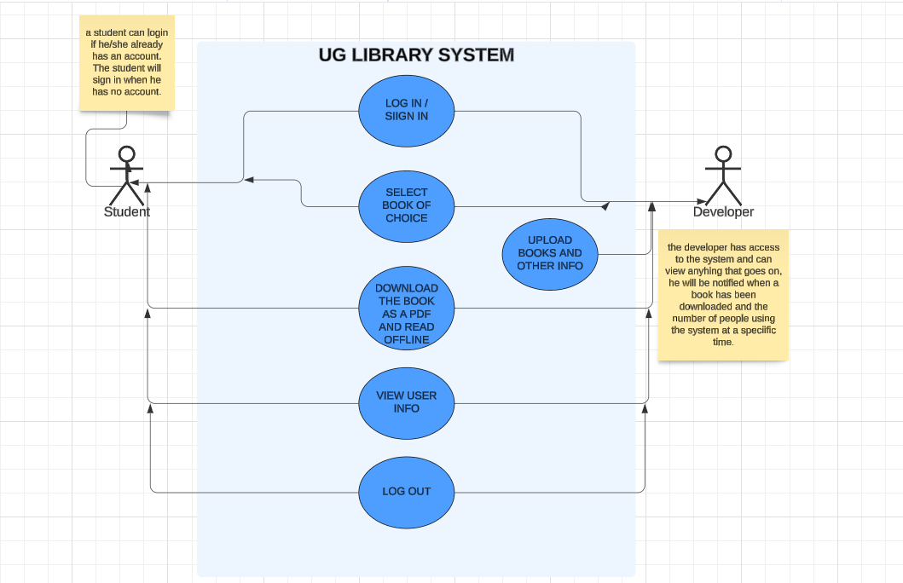

**FLOWCHART:**

